TutorTube: Triads Spring 2019
Introduction
Hello and welcome to TutorTube, where The Learning Center’s Lead Tutors help you understand challenging course concepts with easy to understand videos. My name is Darren Churn, Lead Tutor for Music Theory. In today’s video, we will explore qualities, roman numerals, inversions, and ways to write them. Let’s get started.
Qualities of Triads
There are 4 qualities of triads. Major, minor, augmented, and diminished.
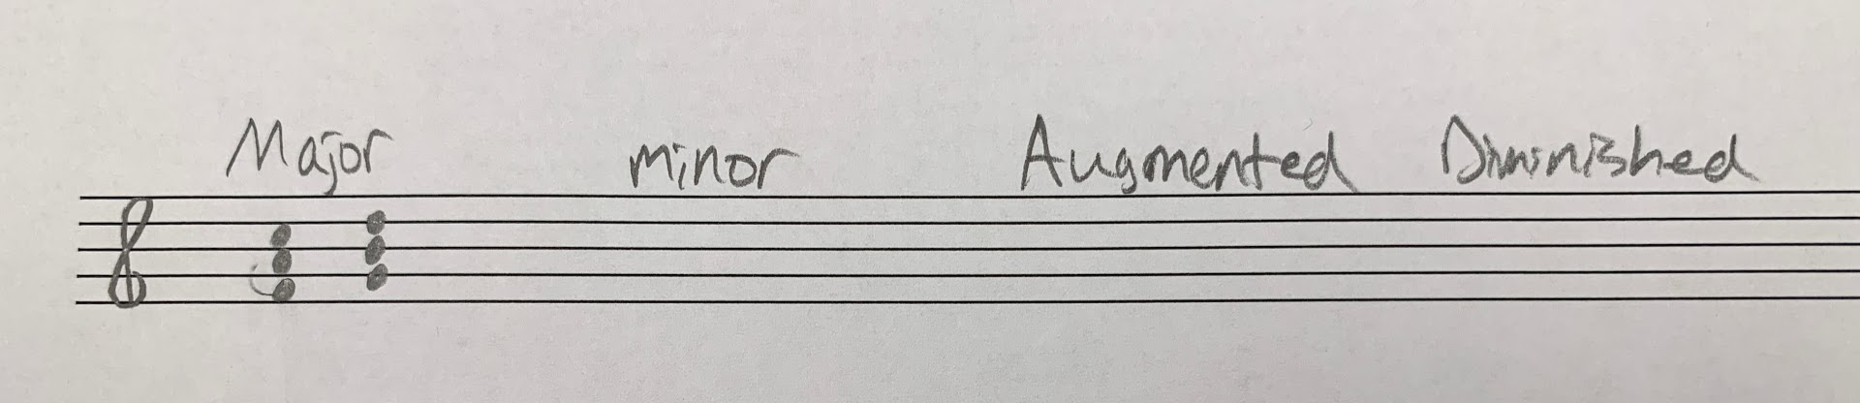
Figure 1
These triads are named based on the intervals that are created with the notes in the chord.
Major
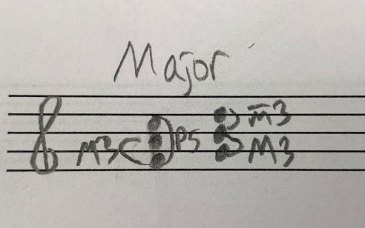
The first type of triad is a Major triad.
Figure 2
Major triads are created by a Major 3rd or 4 half steps away from the root of the chord along with a perfect 5th or 7 half steps away from the root. Here we have an FAC chord. C is a perfect 5th away from F and A is a Major 3rd from F. Another way you can thing about it is a Major 3rd plus a minor 3rd which is only 3 half steps away. With this E major chord, we have G# which is a major 3rd away from E. And we also have B which is a minor 3rd above G#.
Minor
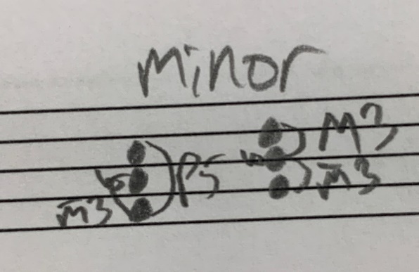
Minor chords on the other hand are built slightly different.
Figure 3
Now instead of 4 half steps away, a minor 3rd is created using 3 half steps. Similar to a Major 3rd chord, there is still a perfect 5th interval from the root. You can also think of this chord as a minor 3rd plus a Major 3rd stacked on top.
Augmented
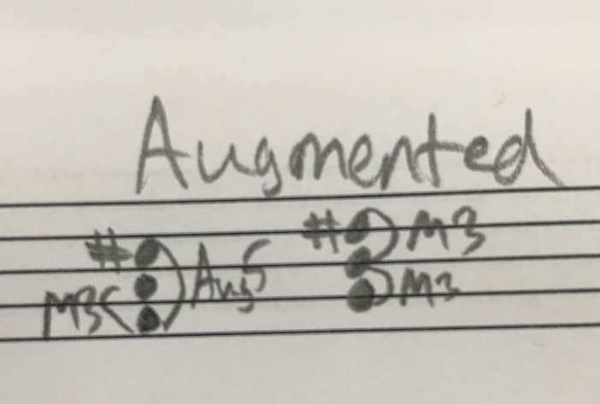
Augmented triads are built by using a Major 3rd and an Augmented or raised 5th. Or you can think of it as stacking two Major 3rds on top of each other. Either way, the 5th of the chord has been raised to create an augmented triad.
Figure 4
Diminished
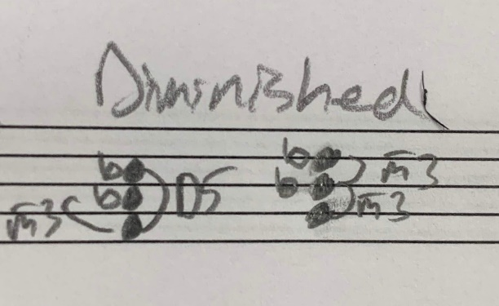
Diminished triads are built by a minor 3rd and a Diminished or Lowered 5th. Or you can think of it as stacking two minor 3rds on top of each other. Diminished chords involve the lowering of the 5th of the chord versus augmented chords which involve raising the 5th.
Figure 5
Roman Numeral Qualities
Now that we have seen the types of qualities of triads, let’s apply them to Major and minor key signatures.
Major
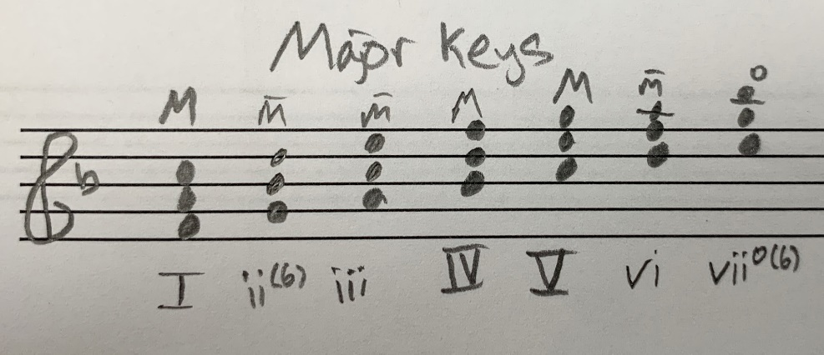
Generally, if a triad is built on a specific scale degree in a Major key, they are the same quality for all Major scales due to the fact that all Major scales have the same succession of intervals. When analyzing the quality of chords, we use upper or lower case roman numerals. Major chords are uppercase and minor chords are lowercase. In a major key, a triad built on the 1st scale degree is major because it almost always contains a Major 3rd and a P5. A triad built on the 2nd scale degree is usually minor because there is a minor 3rd and a P5. Something to take note of is that in order to help maintain smooth voice leading, a ii chord is normally in first in version. So it would be a minor ii6. A triad built on the 3rd scale degree is also minor. The 4th scale degree, major. The 5th scale degree major. The 6th scale degree, minor. The 7th scale degree is diminished due to the minor 3rd and the D5 and usually occurs in first inversion as well.
Figure 6
Now you have seen all the diatonic triads for major keys.
Minor
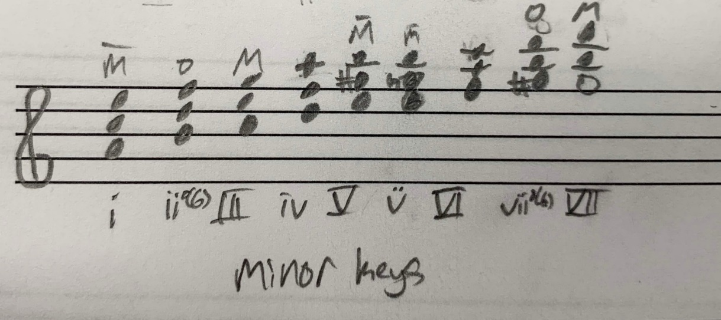
Now we will do the Roman numeral qualities for minor keys. In a minor key, a triad built on the 1st scale degree is minor. A triad built on the 2nd scale degree is diminished and it will still generally be in first in version. A triad built on the 3rd scale degree is major. The 4th scale degree, minor. The 5th scale degree is major if there is a leading tone (raised 7th scale degree) or sometimes can be seen as minor if there is a subtonic instead. This change in note can be seen depending on the use of natural or harmonic minor. The 6th scale degree is major. The 7th scale degree is diminished if there is a leading tone but major if there is a subtonic but stays in first inversion.
Figure 7
Inversions
Now we are going to go more depth into inversions. Inversions refer to what note is in the bass in relation to what the root of the chord is.
Root
A root position chord is read in the figure bass as nothing or 5/3. The 5/3 refers to the intervals above the bass. A root position chord has the root in the bass. If we take a F major triad. That means that a F would be in the bass and then the notes of the chord would exist at a 3rd and a 5th above the bass. Those notes would be A (a 3rd) and C (a 5th).
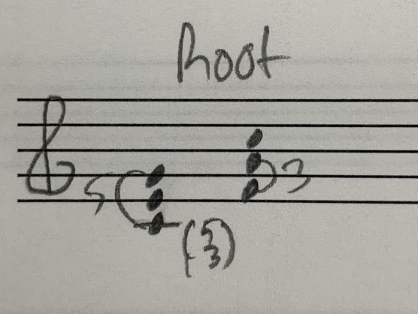
Figure 8
First Inversion
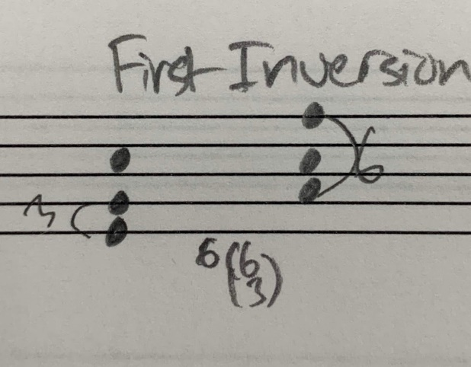
A first inversion chord means that the 3rd of the chord will be in the bass. The inversion is written in the figured bass as 6/3 or simply 6. This means that the rest of the chord exists a 3rd and a 6th above the bass. If we look at F major again. Now we would have C in the bass. A 3rd above A is C and a 6th above A is F. We still have the same notes and quality, but now the note in the bass is an A.
Figure 9
Second Inversion
A second inversion chord means that now the 5th of the chord will be in the bass. Second inversions are written as 6 over 4. According to the figured bass, this means that the rest of the notes of the chord exist at a 4th and a 6th above the note in the bass. For an F major triad, that would mean we would have a C in the bass. A 4th above C is F and a 6th above C is A. These notes fill out the rest of the F Major triad.

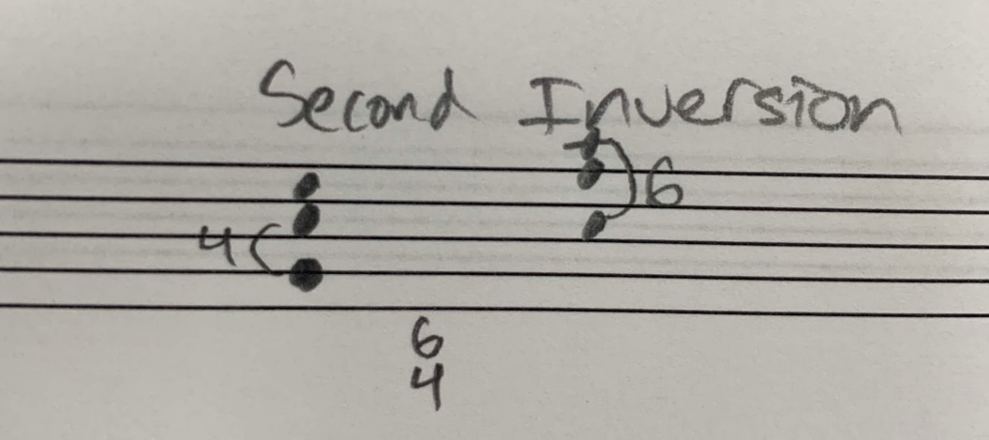
Figure 10
Ways to Write Triads
When starting your part writing, there are two ways to present your voicing. These are called open and closed position. When talking about open vs closed position, we are referring to the position of the top three voices: the soprano, alto and tenor.
Open
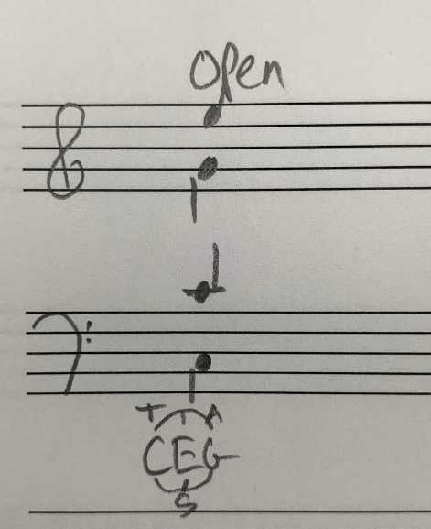
In open position, the notes are spaced out. This happens because of how you form the chord. When using open voicing, you will choose a note in the triad for your tenor, then you will skip the next note in the order for thirds and choose the next note for your alto. Then the same thing from alto to soprano. You are choosing every other note in the chord and then placing it in a different voice. If we start with a C in the tenor the note skipped would be E and the next note would be G. You would then skip C and the next note placed would be E.
Figure 11

Closed
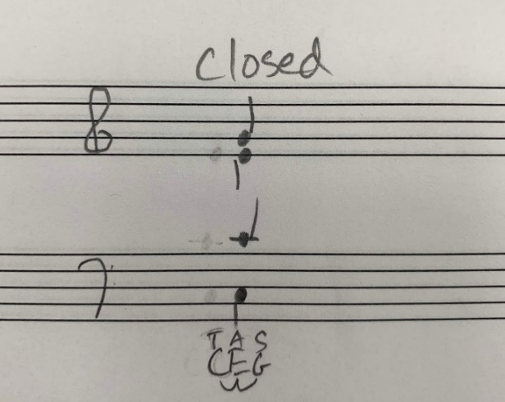
In closed position, the voices are closer together. Now when you look at the notes of the triad, instead of skipping a note, you will place each one in order. Starting with the tenor, you will choose part of that chord, then place the next two in order in the alto and soprano. We start with a C in the tenor, then go to an E in the alto and then to a G in the soprano. As you can see, the voices now seem much closer together, even though they are the same chord.
Figure 12
Summary
We learned a lot of different things today so here is a quick summary of what we covered.
Qualities
Recall there are 4 primary types of triads. Major, minor, augmented, and diminished. Major and minor triads both have a Perfect 5th but a Major a minor third that distinguish them. Augmented chords have a Major third and an Augmented 5th. Diminished chords have a minor third and a diminished 5th.
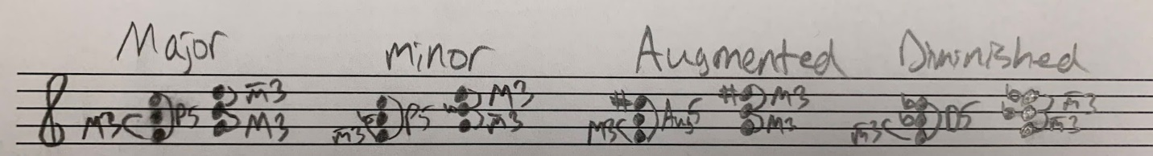
Figure 13
Roman Numerals
Roman numerals are determined by the quality of the triads built on that specific scale degree. Each Major and minor key follows the same pattern due to the use of the same intervallic structure. If you are ever unsure of the roman numeral for a specific scale degree, build a triad on that note and use the key signature provided and analyze the intervals.
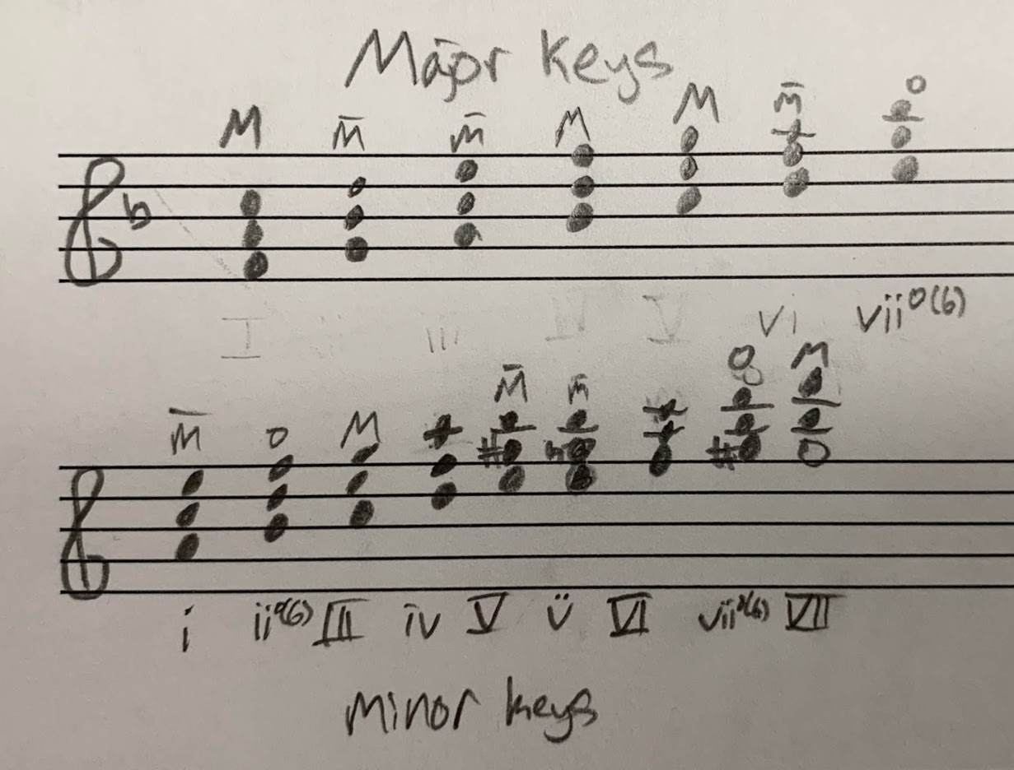
Figure 14
Inversions
For triads, there are three positions a chord can potentially be in. Root position is written with nothing or 5/3 in the bass and is where the root of the chord is also in the bass. 1st inversion is written as a 6 in the figured bass and is where the 3rd of the chord is in the bass. 2nd inversion is written as 6/4 and is when the 5th of the chord is in the bass.
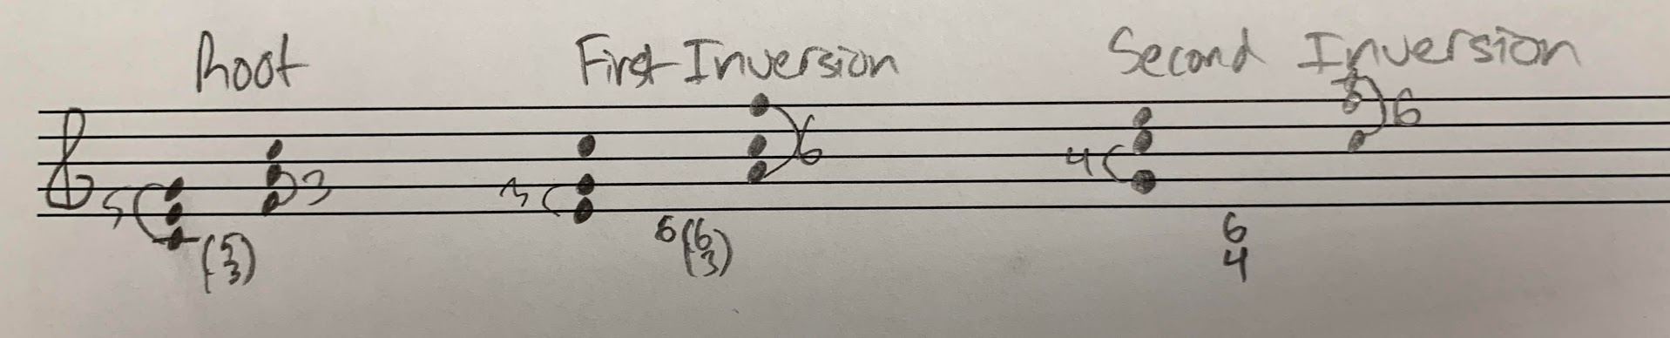
Figure 15
Ways to Write Triads
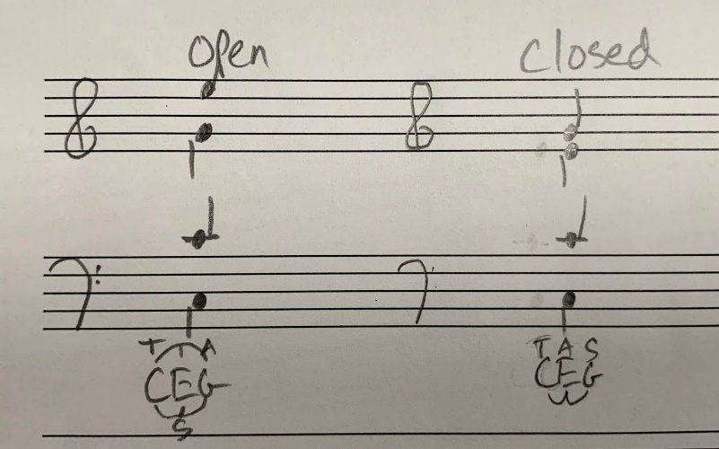
In terms of spacing, there are two primary types of voicing when doing SATB part writing. There is open position which is when the voices are more spaced out due to the SAT using every other note in the chord. Closed position forces the voices to be closer together because each note in the chord is used in order in the SAT.
Figure 16
Outro
Thank you for watching TutorTube. I hope you enjoyed this video. Please subscribe to our channel for more exciting videos. Check out the links in the description below for more information about The Learning Center and follow us on social media. See you next time.

